# Historical use of Interior Design Principles.

Before we focus on the Principles of Interior Design, it is important to understand that the industry is part of a larger umbrella of theories that apply to all areas of Art & Design. The initial idea of Art & Design theory focused on these in a more holistic manner, looking at the implementation of them in a generic approach.

As previously discussed, the Interior Design Principles provide guidelines for creating effective visual designs. Understanding how these have developed, and the way in which they are present throughout history, can give us a more solid understanding of the way in which they can be implemented in our own practice. Although there is a gap in the history of the Theory of Interior Design in this area, and not many official writings on how the Principles of Interior Design developed and evolved, in this article, we will attempt to look at how the Design Principles developed from practical ideas and implementation, to solidified theories that are taught and used in the Industry.

# The Development of the Principles

The foundations of the Design Principles can be traced back to ancient civilisations, but their formal codification began in the late 19th and early 20th centuries. As art and design in education became more structured, educators and theorists sought to define the fundamental elements and principles that make up effective visual communication.

The roots of the Design Principles can be traced back to ancient civilisations. Ancient Egyptians, Greeks, and Romans all followed certain aesthetic rules in their architecture and art, although these weren't formally codified as "principles."

The Greeks, in particular, were fascinated by proportion and harmony. They developed the concept of the Golden Ratio, which they believed created the most aesthetically pleasing compositions. This ratio can be seen in the design of the Parthenon and other classical structures.



Fig. 1. Pexels (2024), The Parthenon, Aerial View

During the Renaissance (14th-17th centuries), artists and architects began to more systematically explore and document design principles. Leonardo da Vinci's studies on the human form, proportion and perspective, laid important groundwork for future design principles. His Vitruvian Man (Fig 2) drawing showcases his explorations of the ideal human proportions.

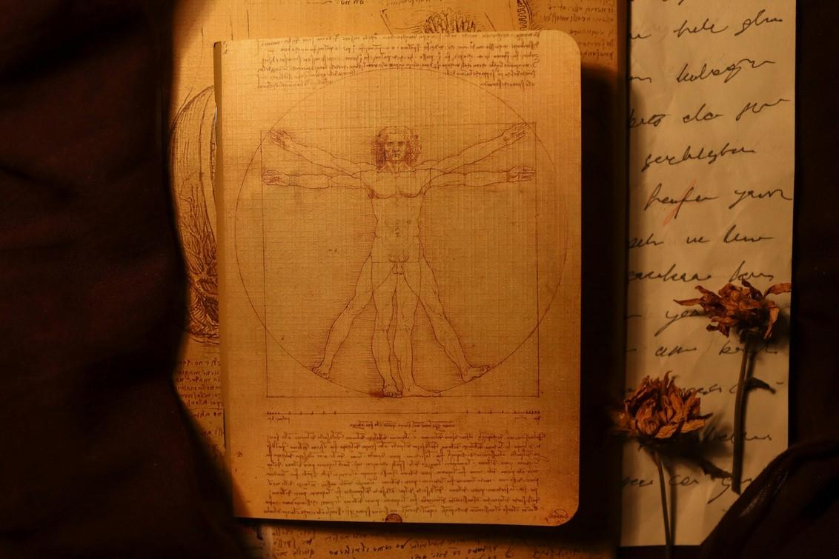

Fig. 2. Pexels (2024), The Vitruvian Man

In 1435, Alberti wrote "De Pictura" (On Painting), which was one of the first formal writings on the principles of artistic composition. He discussed concepts like proportion, harmony, and the use of geometry in art. In 1704, Isaac Newton is believed to have created the first modern colour wheel. He introduced the first design of the modern colour wheel in his book Opticks, where he arranged seven colours (red, orange, yellow, green, blue, indigo, and violet) into a circular diagram

Design theory saw significant developments during the 19th century, which is largely due to a reaction to the mass production of the Industrial Revolution. William Morris, who was a key figure in the Arts and Crafts movement, emphasised the importance of craftsmanship and the integration of form and function. One of his beliefs was that patterns should have “beauty, imagination and order”. This movement laid the groundwork for many modern design principles, particularly the idea that good design should be both beautiful and practical.

The Bauhaus movement, along with other parallel movements of the 20th century brought on significant changes in design thinking, with groundbreaking ideologies brought to the forefront. Walter Gropius, the founder of the Bauhaus school, sought to unify art, craft, and technology. The school developed a holistic approach to design education that included studies of colour, form, and materials.

Johannes Itten, who was a Bauhaus teacher, developed influential theories on colour that are still taught today. He developed the theories behind colour schemes, and the fact that there are seven types of contrast: hue, extension, light-dark, saturation, complementary, analogous, and cold- warm. His work on colour contrasts and harmonies became fundamental to understanding colour in design. His book “The Art of Colour” examines colour as both “subjective feelings” and

“objective colour principles”.

During this time, designers and educators began to more formally articulate and to teach design principles. A good example of this are the Gestalt principles (such as similarity, continuity, and closure), which were developed by German psychologists in the 1920s. By the 1950s and 60s, they were widely used in design education. These principles, in their core, explain how humans perceive and organise visual information.

The late 20th century sees the development of new theories that are particular to certain specialisms and industries, such as Interior Design, Graphic Design etc., as well as the reaffirmation of the traditional principles mentioned above. In the 1980s and 90s, Don Norman's work on user-centred design introduced principles focused on usability and user experience (UX design), which have become crucial in digital design and the development of the design software we use today.

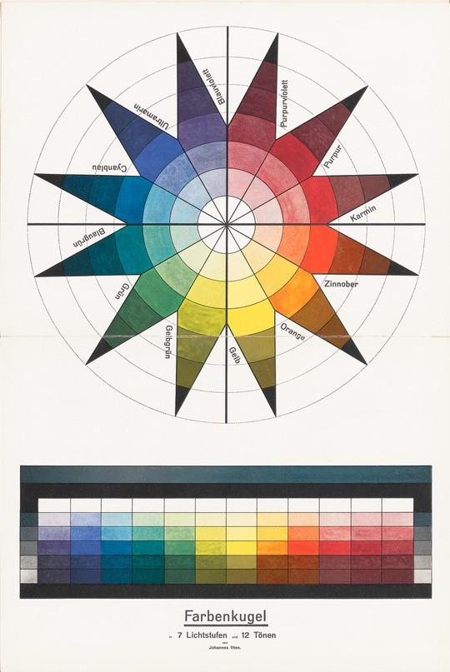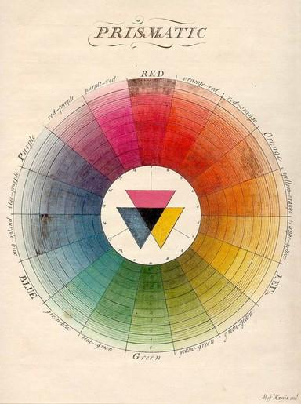

Fig. 3. (Weimar, 1921), Johannes Itten’s Colour Star, Farbenkugel in 7 Lichtstufen und 12 Tönen (Color sphere in 7 light values and 12 tones), Johannes Itten, 1921. Lithograph. 74.3 x 32.2 cm. From Bruno Adler, ed., Utopia: Dokumente der Wirklichkeit I/II, fold out from inside cover.

Fig. 4. Claude Boutet (1708), Claude Boutet’s 7‑colour and 12-colour circles (top), based on Newton’s Theories

Throughout history, the Design Principles have evolved from intuitive rules, to formally articulated guidelines, adapting to new technologies and societal needs, while maintaining core ideas about aesthetics, functionality, and human perception. Let us look at some examples of the application of the Design Principles throughout the history of Interior Design and Architecture.

# Design Principles applied in History

Interior design principles have evolved over centuries, shaping the way we create and experience living spaces. Let's explore the history and application of key principles in interior design:

## Dominance

The concept of dominance in interior design can be traced back to ancient Egyptian and Roman architecture, where grand entrances and central halls dominated the overall structure.

Historical Example: The Great Hall of Hatshepsut's Temple (1470 BCE) in Egypt showcases a perfect example of dominance through its imposing colonnade, and central positioning.

Modern Application: In contemporary interiors, dominance is often achieved through a statement piece, such as an oversized chandelier in a minimalist living room or a bold accent wall in a neutral bedroom.

## Rhythm

Rhythm in interior design emerged as a principle during the Renaissance period, with repeating architectural elements creating a sense of movement and harmony.

**Historical Example:** The Palace of Versailles (17th century) showcases rhythm through its repetitive use of arched windows, ornate mouldings, and symmetrical layouts.

**Modern Application:** Today, rhythm can be created through the repetition of colours, patterns, or textures. For instance, a series of identically framed artworks along a hallway or a recurring geometric pattern in throw pillows and curtains.

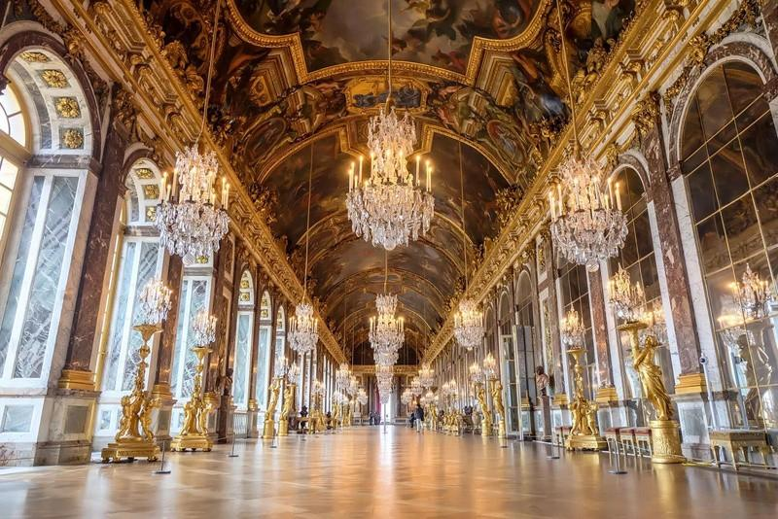

Fig. 5. Britannica (2024), The Hall of Mirrors, Palace of Versailles

## Focal Point

The use of focal points became prominent in the Baroque period, where elaborate ceiling frescoes or ornate fireplaces drew the eye.

**Historical Example:** The Painted Hall at the Old Royal Naval College in London (early 18th century) features a stunning ceiling fresco that serves as the room's focal point.

**Modern Application:** In contemporary design, a focal point might be a feature wall with unique wallpaper, a striking piece of furniture, or a large-scale artwork. For example, a freestanding bathtub in a minimalist bathroom or a dramatic kitchen island in an open-plan space.

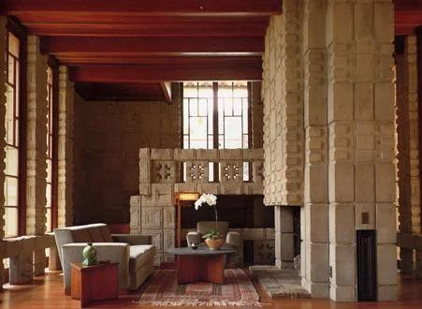

Fig. 6. The Musings of a Preservationist (2024), TheStorer House Interior

## Scale

The importance of scale in interior design was emphasised during the Industrial Revolution when mass production led to a wider variety of furniture sizes.

**Historical Example:** The Storer House by Frank Lloyd Wright (1923) demonstrates Wright's mastery of scale, with furniture and architectural elements perfectly proportioned to create a harmonious whole.

**Modern Application:** In modern interiors, playing with scale can create visual interest. Oversized pendant lights in a kitchen or a large sectional sofa in a small living room can make impactful statements.

## Proportion

Proportion as a design principle dates back to ancient Greece and the concept of the Golden Ratio.

**Historical Example:** The Pantheon in Rome (126 AD) is renowned for its perfect proportions, with the height of the rotunda exactly equal to its diameter.

**Modern Application:** In contemporary interiors, proportion is crucial for creating balanced spaces. This might involve choosing furniture that fits the room's dimensions or ensuring that the size of a rug is proportional to the seating area it anchors.

## Balance

The concept of balance in interior design can be traced back to the symmetrical layouts of Renaissance palaces and gardens.

**Historical Example:** The Château de Vaux-le-Vicomte in France (17th century) showcases various types of balance, with its symmetrical gardens and interior layouts.

**Modern Application:** Modern designers often use asymmetrical balance for a more dynamic feel. This could involve pairing a large sofa on one side of a room with two smaller chairs and a side table on the other, creating visual equilibrium without perfect symmetry.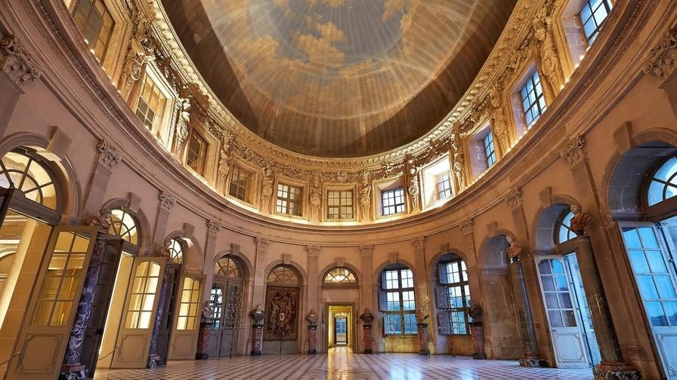

Fig. 7. Conde Nast Traveller (2024), Château de Vaux-le-Vicomte

## Contrast

The principle of contrast in interior design has roots in ancient civilizations, where it was used to create visual interest and emphasise important elements. However, it gained particular prominence during the Art Deco movement of the 1920s and 1930s.

**Historical Example:** The Chrysler Building's lobby in New York City (1930) is a prime example of Art Deco's use of contrast. The space features striking juxtapositions of materials, with dark wood veneer contrasting against light-coloured marble, and matte surfaces playing against highly polished ones.

**Modern Application**: In contemporary interiors, contrast is used to create visual excitement and define spaces ,through materials, colours, textures, forms and shapes.